Ahmad Siddiq Priaji (22/496854/PA/21370)

**(1)**

Kode :

public class TestMonster {

    public static void main(String[] args) {

        //create instances of three monsters (m1,m2,m3) and initialize their fields

        Monster m1 = new Monster();

        m1.name = "Golem";

        m1.hp = 1000;

        m1.mp = 300;

        m1.item = "Diamond";

        Monster m2 = new Monster();

        m2.name = "Slime";

        m2.hp = 300;

        m2.mp = 200;

        m2.item = "Slime Condensate";

        Monster m3 = new Monster();

        m3.name = "Dark Knight";

        m3.hp = 2000;

        m3.mp = 1000;

        m3.item = "Sword of Darkness";

        //declare an array monsters with type Monster and size = 3

        Monster[] monsters = new Monster[3];

        //initialize the array with m1,m2,m3

        monsters[0] = m1;

        monsters[1] = m2;

        monsters[2] = m3;

        //print all monsters in the array

        for(int i = 0; i < monsters.length; i++) {

            System.out.println("A monster has appeared! " + monsters[i].name + " HP:" + monsters[i].hp + " MP:" + monsters[i].mp);

        }

    }

}

Hasil:

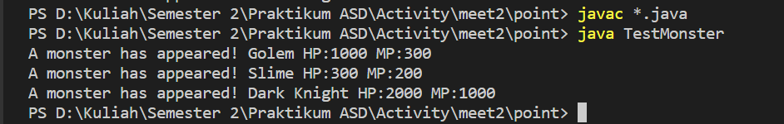

**(2)**

Kode :

public class TestMonster {

    public static void main(String[] args) {

        //create instances of three monsters (m1,m2,m3) and initialize their fields

        Monster m1 = new Monster();

        m1.name = "Golem";

        m1.hp = 1000;

        m1.mp = 300;

        m1.item = "Diamond";

        Monster m2 = new Monster();

        m2.name = "Slime";

        m2.hp = 300;

        m2.mp = 200;

        m2.item = "Slime Condensate";

        Monster m3 = new Monster();

        m3.name = "Dark Knight";

        m3.hp = 2000;

        m3.mp = 1000;

        m3.item = "Sword of Darkness";

        //declare an array monsters with type Monster and size = 3

        Monster[] monsters = new Monster[3];

        //initialize the array with m1,m2,m3

        monsters[0] = m1;

        monsters[1] = m2;

        // monsters[2] = m3;

        //print all monsters in the array

        for(int i = 0; i < monsters.length; i++) {

            System.out.println("A monster has appeared! " + monsters[i].name + " HP:" + monsters[i].hp + " MP:" + monsters[i].mp);

        }

    }

}

Hasil:

